*22AIE204 Introduction to Networks Labsheet4*

**Analyzing the network performance for internet applications**

Roll No: **AM.EN.U4AIE22010**

Name : Anuvind MP

**Problem 1**

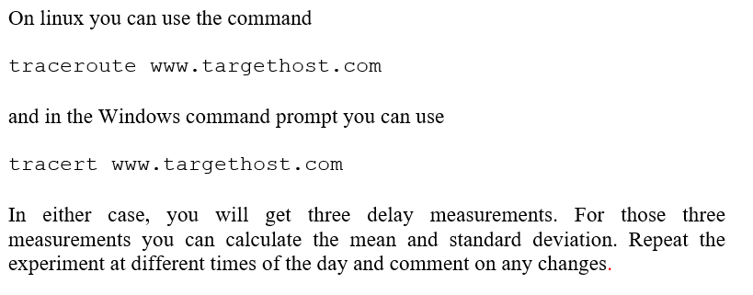

**Morning 8 am:**

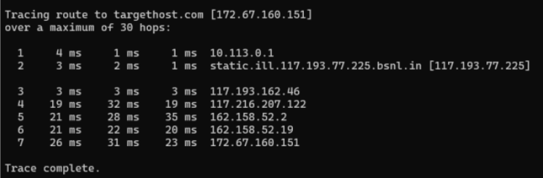

**Mean:** 26.67 ms

**Standard Deviation:** 4.0414 ms

**Afternoon 1 pm :**

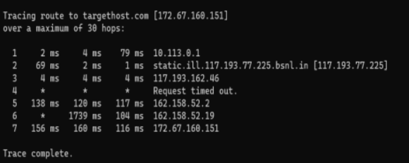

**Mean:** 144 ms

**Standard Deviation:** 24.3310 ms

**Night 10 pm:**

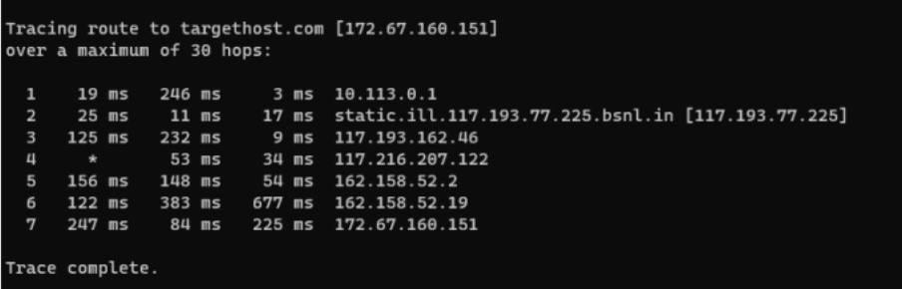

**Mean:** 185.3333 ms

**Standard Deviation:** 88.4439 ms

The average length of time seems to increase notably during the night, but shortens significantly in the morning. This pattern suggests that lower demand in the morning leads to quicker response times, whereas higher demand at night causes delays to increase.

**Problem 2**

Analyze the different aspects of the HTTP protocol in the Wireshark: the basic

GET/reply interaction, HTTP message formats, retrieving HTML files with embedded

URLs, persistent or nonpersistent connections, and HTTP authentication/security

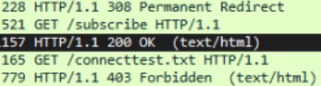

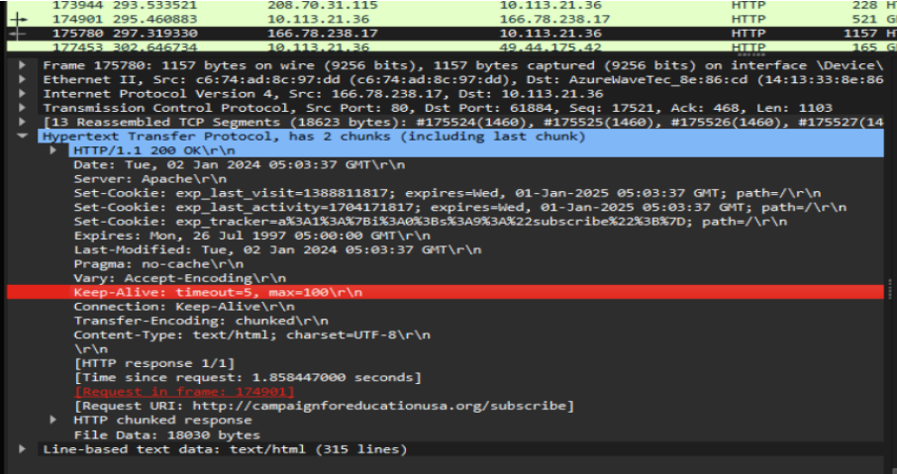

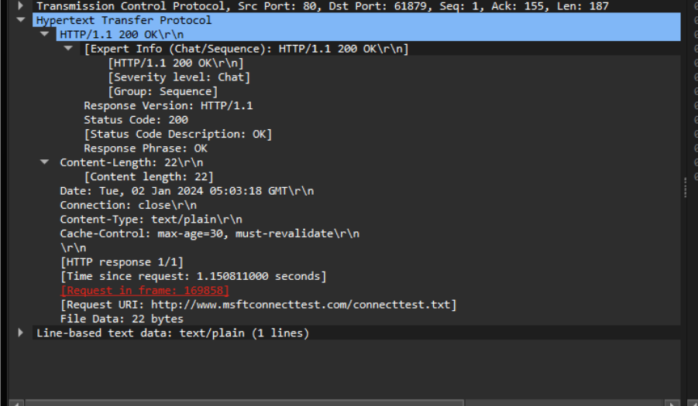

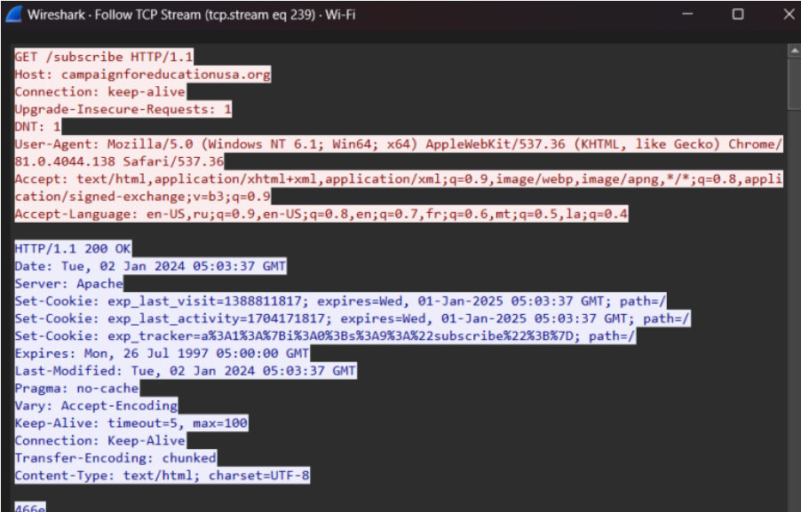

The above images showcases the interaction of an HTTP packet with TCP, illustrating the exchange between a GET request and a 200 OK response. It also presents the formats of both the request and response messages, consistently indicating the HTTP version each time. Additionally, it includes a status code and the type of request.

**Problem 3**

Download the open source startrinity software for continuous internet speed test tool - [Continuous internet speed test tool (startrinity.com)](http://startrinity.com/InternetQuality/ContinuousBandwidthTester.aspx)

Select any of the internet applications that takes long time to evaluate. Analyze for packet loss, delays in accessing the internet applications for a long time based on differences in the internet speed.

Example: Video conferencing services –gmeet, zoom, teams, Video streaming services – YouTube, gaming applications etc.

Start the continuity speed test and capture the frames in Wireshark while you are using the selected internet application for 10 to 15 minutes. Analyze the mean andstandard deviations of packet loss, delay with respect to changing internet speed from the csv file output of startrinity and analyze the throughput in wireshark

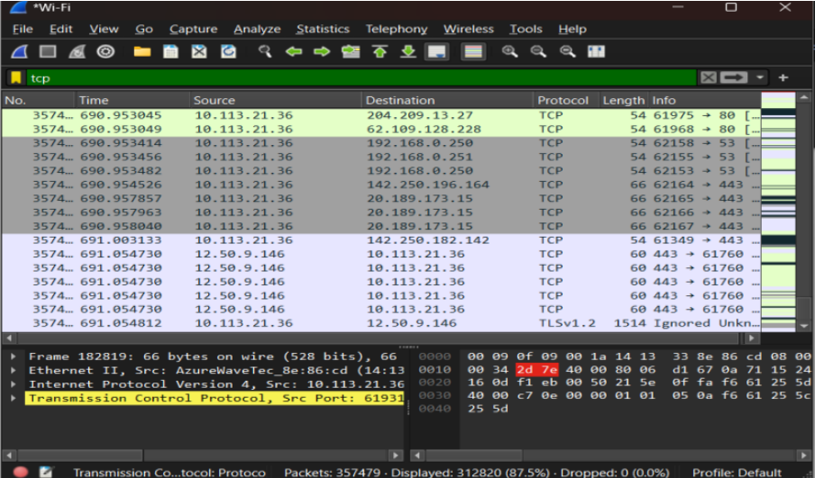

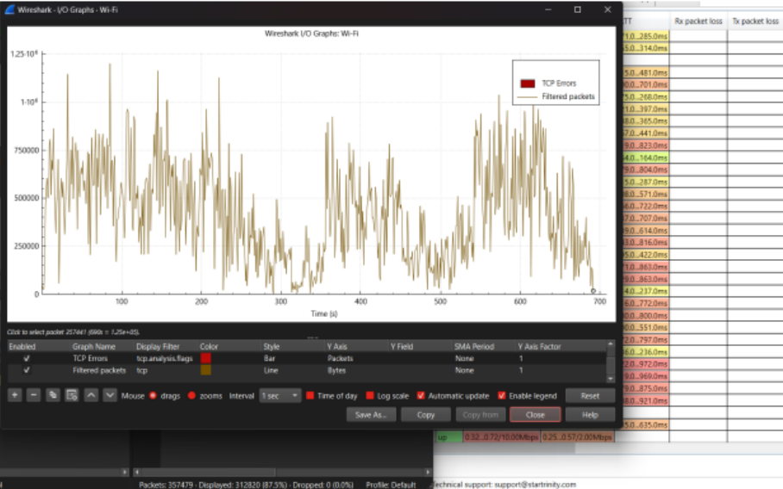

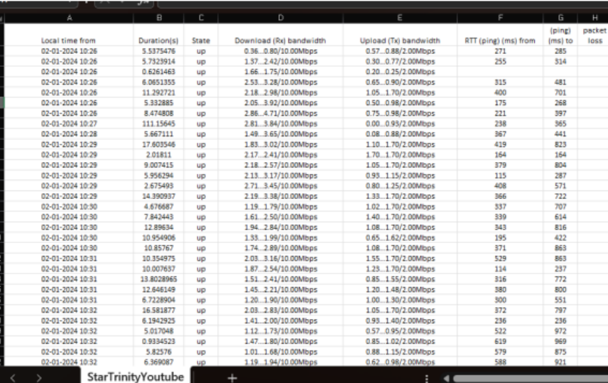

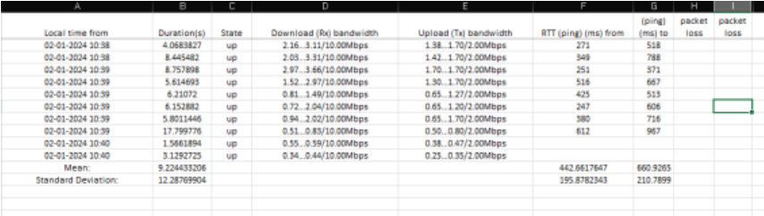

The CSV file generated by StarTrinity indicates no packet loss. The lowest throughput was observed at 290 seconds with 781 bytes, while the highest throughput occurred at 531 seconds with 1.037 * 10^6 bytes. The mean and standard deviation values are available in the screenshots for reference.